Company Profile



Table of Contents

- Executive Summary
  - About Dial Bangla
  - About the BPO Industry
  - Impact in Bangladesh

- Company Information
  - Employee Training
  - Assurance on Quality
  - Organizational Chart

- Company Services

- Standard Operating Procedures (SOP)

- Targeted Industries for Business

Executive Summary
About Dial Bangla

Dial Bangla founded in 2017 with a vision to cater to the customers excellence, back office & BPO services.

Dial Bangla offers both Information Technology and Business Process Outsourcing Solutions. With our industry expertise and offshore liaison at the whole world, we are committed to provide maximum value, high quality and low cost Business Processing and IT services to our prospective clients. We have teams of dedicated and experienced e-business consultant, application developers, e-marketer, web promoters, multimedia and graphic designers. We are specialized in VA (Virtual Assistant) works like skip tracing, web research, cold calling, appointment setting, telemarketing and data entry. We write articles, blogs, contents as well.

About the BPO Industry

Business process outsourcing (BPO) is a subset of outsourcing that involves the contracting of the operations and responsibilities of a specific business process to a third-party service provider. Originally, this was associated with manufacturing firms, such as Coca-Cola that outsourced large segments of its supply chain.

BPO is typically categorized into back office outsourcing, which includes internal business functions such as human resources or finance and accounting, and front office outsourcing, which includes customer-related services such as contact centre (customer care) services.

BPO that is contracted outside a company's country is called offshore outsourcing. BPO that is contracted to a company's neighbouring (or nearby) country is called nearshore outsourcing. Often the business processes are information technology-based, and are referred to as ITES-BPO, where ITES stands for Information Technology Enabled Service. Knowledge process outsourcing (KPO) and legal process outsourcing (LPO) are some of the sub-segments of business process outsourcing industry.

Impact in Bangladesh

Today, Bangladesh, the BPO ring is the most upcoming and rapidly growing industry, attracting the educated mass youth all over the country for jobs that inspire and offer a creative method of income. The BPO workforce offers several advantages over their Western counterparts, both in terms of cost savings (low cost labor) and availability of resourceful manpower.

The Revenue generation by BPO Industries in Bangladesh is now much higher than those of previous years.

Predictions of revenue growth in Bangladesh's BPO Industry within the next Five years is approximately US$ 5 Billions. Eventually, the BPO Industry will spread its service sets and expand into other industries. Banking sectors and other financial firms are undergoing significant cost-reduction pressure and are therefore planning to streamline their core functions by outsourcing their functions to BPO Service Providers.

Employee Training

Training is a key and integral part for a Company’s successful Operations process. New employees are evaluated from the first day of their interview, using various methods of evaluation and identification and combining the perspectives of other staff, colleagues and superiors, upon their interaction with the incumbents.

Such employees, when inducted into the flow of operations according to their designated positions, are constantly evaluated via the Appraisals program, where a panel comprising of a member each from the Human Resources, Training and an immediate Supervisor, notes specific points of advantageous skills and identifies the weak spots, duly marking for improvement and/or re-training.

This process is a continuously evolving process, during the timeline of the employee in the company and is aimed towards harnessing the full potential of the employees in question, ultimately resulting in a highly productive workforce.

Assurance on Quality

Here at Dial Bangla, the process involved for each client is heavily governed by our drive to achieve the highest quality standards possible.

In order to achieve this, each aspect of the process is scrutinized to ascertain the lowest levels of low productivity. From the supplied materials to the supplied personnel, frequent checks are made to identify improvements that can be done, allowing a higher percentage of quality. The Project Manager assigned for each client’s process is of the highest caliber and it is in him/her that enormous trust is placed, to ensure the level of quality achieved is not below expectations.

Our Quality Assurance team is built on such parameters, where the identification of even the most insignificant weak spot is held to be a threat that needs to be removed. Coupled with the principles of our Senior Management, such endeavors are possible to be made to our clients, thus reinforcing their individual value to the company.

Call Center Operation Organizational Chart

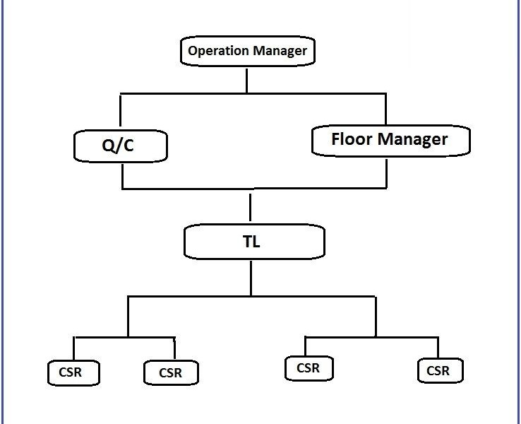

Company Services

To carry out the business of verity of Call centers are used by mail-order catalog organizations, telemarketing companies, computer product help desks, and any large organization that uses the telephone to sell or service products and services. By two related terms are virtual call center and contact center. Other names for a call center agent include customer service representative (CSR), telephone sales or service representative (TSR), attendant, associate, operator, account executive or team member by getting international gateway from respective authorities. The contact center typically includes one or more online call centers but may include other types of customer contact as well, including e-mail newsletters, postal mail catalogs, Web site inquiries and chats, and the collection of information from customers during in-store purchasing. A contact center is generally part of an enterprise's overall customer relationship management (CRM).

Standard Operating Procedures
Identification of Requirements for;

- Project Work Parameters
- Contact Center Parameters
- Scope of Work Parameters
- Staffing Parameters
- Management and Future Development Parameters
- Financial Parameters

Planning is an important aspect in generating successful processes. The steps are;

- Requirements Analysis Stage
- Arrangement and Environment Setup Stage
- Development Stage
- Networking Connectivity Stage
- Software Integration Stage
- CRM Implementation Stage
- Final Testing Stage
- Live Operation

Targeted Industries for Business

Dial Bangla has a highly diversified, unique and cutting-edge handful of service sets. Such service sets can be used in almost any active industry, provided the presentation and implementation phases are carried out well.

Targeted industries;

- Lenders
- Real Estate
- Health and Pharmaceutical Services
- Logistics
- Travel, Ticketing and Tourism
- Telecommunications
- Education
- Insurance Services

Companies who trust us

Explore the esteemed companies who entrust Dial Bangla with their digital needs. We take pride in this trust, motivating us to consistently surpass expectations and provide innovative solutions. Here’s a list of our clients

- Antaranga Dot Com Limited
- Antaranga Networks
- Colo71
- Metabolic Design Bangladesh Limited
- ColoCone
- CityLink Communication

